# Instructions for setting up IBM Cloud and requesting promo code

**ATTENTION**: You need to request and apply a promo code to your IBM Cloud account in order to get access to all the features required for you to successfully complete the workshops and project.

* Install and launch Google Chrome web browser.
  + It has been found that IBM Cloud, as well as the IBM Academic Initiative website does not always work properly on other browsers.
* Sign up for an IBM Cloud account. Please ensure you **use your UCL email address**.

<https://cloud.ibm.com/registration>

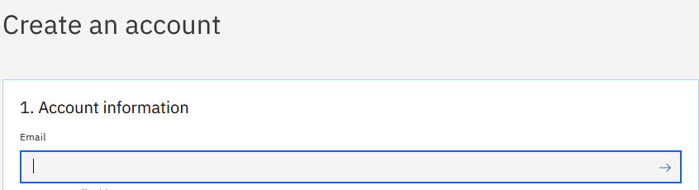

* Now open another tab and navigate to <https://www.ibm.com/academic> .
* Click on “Register now”. Please ensure you use the same UCL email address as that for your IBM Cloud account.
  + **ATTENTION**: Using a different email address might result in you being denied a promo code.

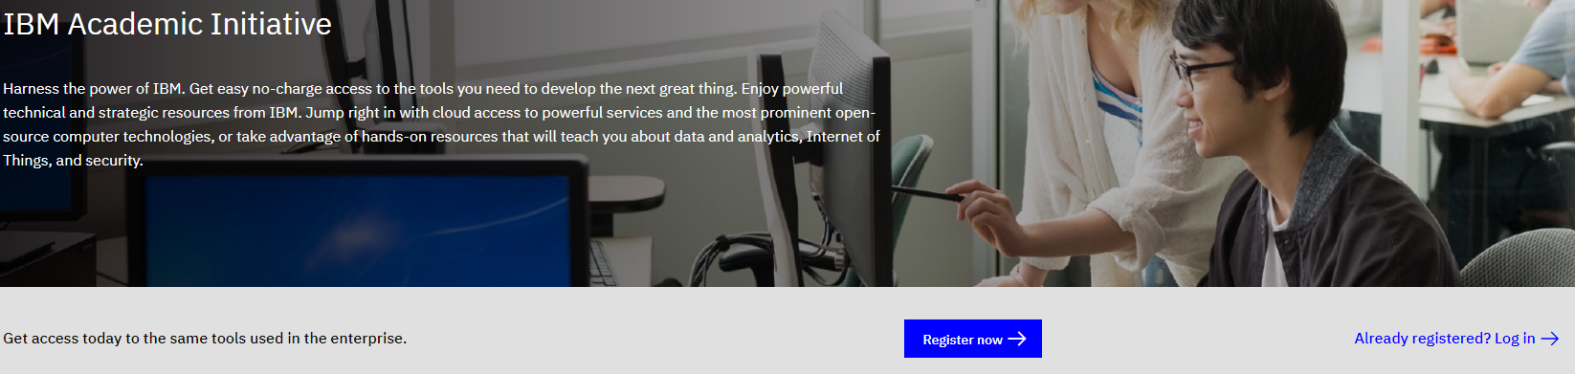

* Once you are signed in, click on the Technology drop-down menu and select IBM Cloud.

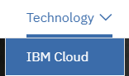

* Scroll down the page, click on the tab called Software and then click on the link “Request Feature Code”.

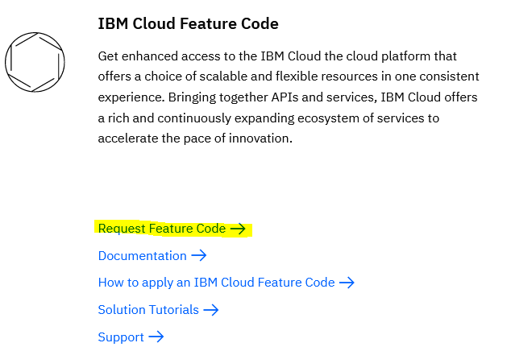

* A pop-up window should then be displayed showing you your promo code. Copy the code and paste it in a document. Store the document safely and securely on your machine.

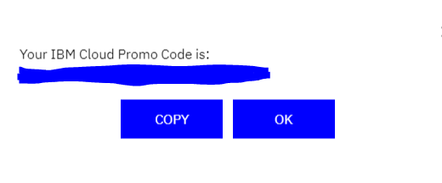

**ATTENTION**: This promo code is **unique** and has been generated solely in connection with your email address. Do not share it or distribute it since you can only apply it once to your IBM Cloud account. If your code becomes unusable for any reason, you will not be able to apply for another promo code.

* Now navigate back to your IBM Cloud account settings:

<https://cloud.ibm.com/account/settings>

* Scroll down the page to “Subscription and feature codes” and click on “Apply code”:

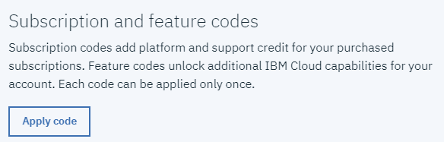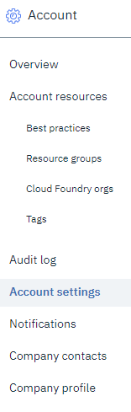

* Paste your code into the box and click Apply.

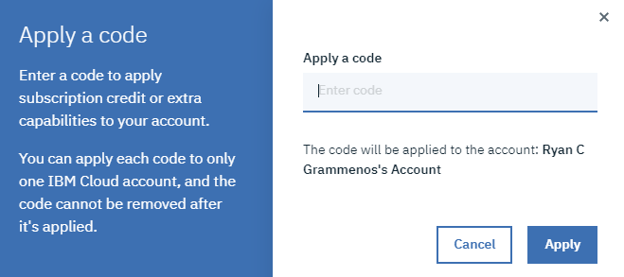

* You now have access to the extended features of IBM Cloud.